IT 493 – Senior Design Project I

Assignment 4.2: Communication Report #2
Course: IT 493-014 – Senior Design Project II
Team: Tour Catchers LLC – Team 4
Sponsor: Sheeraz Ahmad

SECTION 1: Sponsor Communication

Background Information
Tour Catchers LLC is a travel and tourism services company focused on improving its booking operations and customer communication processes. The Capstone project aims to design and implement a technology solution that includes a web booking application, Bitrix CRM integration, and Dialpad AI customer communication tools.
Communication Report #2 documents the second sponsor meeting, where the team presented updates on system testing plans and training preparation. The meeting focused on validating the Test Plan and Use Case scenarios from Assignment 7 and reviewing the Training Plan for employees from Assignment 8.
The purpose of this meeting was to confirm that testing procedures and user training align with the sponsor’s operational needs before final implementation.

1. Meeting Agenda
(Agenda provided to sponsor before the meeting) Proposed Meeting Agenda 4.2.xlsx
Capstone Project – Sponsor Meeting #2
Project: Tour Catchers LLC
Date/Time: March 5, 2026 / 9:00 AM – 10:30 AM
Location/Format: Virtual (Zoom)
Time | Agenda Item | Lead Presenter | Objective
9:00 – 9:05 | Welcome & Meeting Objectives | Jibraan Ahmad | Open the meeting and outline discussion goals
9:05 – 9:20 | Project Schedule & Progress Review | Jibraan Ahmad | Provide update on development progress and project timeline
9:20 – 9:40 | Test Plan & Use Case Review | Anis Mirza | Present testing methodology, test environment, and system validation strategy
9:40 – 9:55 | Product Development Status | Jasleen Kaur | Review progress of booking application, CRM integration, and AI assistant
9:55 – 10:10 | Training Plan Overview | Kainat Khan | Present training structure for staff using the new system
10:10 – 10:20 | Communication Plan Review | Kainat Khan | Confirm sponsor updates and communication schedule
10:20 – 10:30 | Q&A, Feedback & Next Steps | Jibraan Ahmad | Address sponsor questions and confirm next steps

2. Project Status Report

Product Development Status
Task | Risk Level | Planned Dates | Responsible Team Member(s) | Status
Web Booking Application Development | Low | 02/05 – 04/05 | Jasleen Kaur, Dipak Pathak | Completed
Bitrix CRM Setup & Automation | Low | 02/10 – 04/10 | Maaz Mughal | In Progress (Considering alternative CRM due to cost)
Dialpad AI Integration | low | 02/20 – 03/30 | Anis Mirza | In Progress (Verification Completed, Configuration Ongoing)
Test Plan Development & Use Case Testing | Medium | 02/25 – 03/25 | Anis Mirza, Team Members | Ongoing
Training Plan Development | Low | 03/01 – 04/01 | Kainat Khan | In Progress
Project Communication Management | Low | 01/20 – 04/15 | Kainat Khan | Continuous

Communication Plan (Completed & Planned)
Communication Type | Frequency | Audience | Status
Sponsor Progress Meetings | Bi-weekly | Sponsor | Ongoing
Email Status Updates | Weekly | Sponsor | Ongoing
Sprint Progress Reports | End of Sprint | Sponsor | Planned
Training Documentation | Before deployment | Sponsor & Staff | Planned
(Insert screenshot of Gantt chart or roadmap visual from your PPT here for the Project Status Visual.) Assignment 5_IT493 - Product Roadmap-Template.xlsx
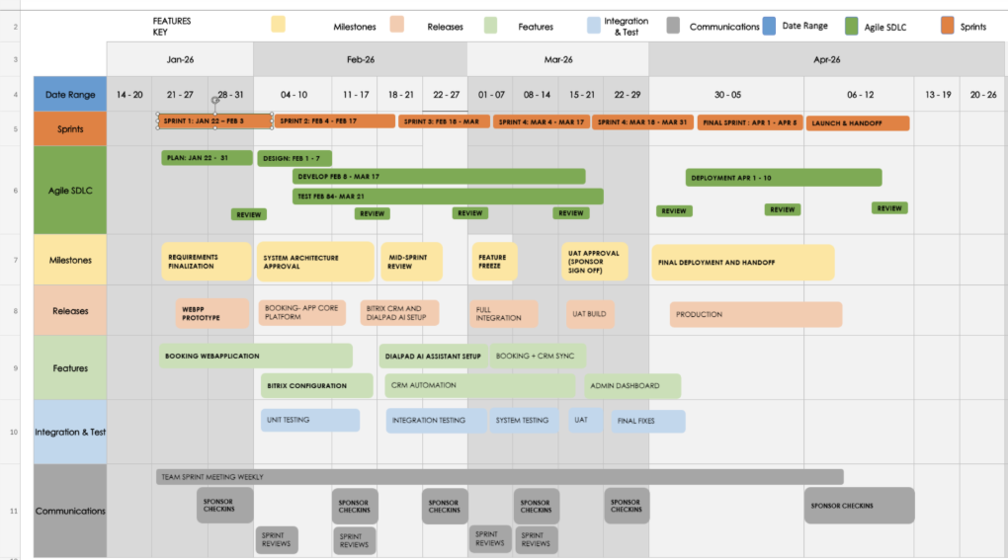

3. Meeting Minutes
Date/Time: March 5, 2026 / 9:00 AM – 10:30 AM
Sponsor Attendees: Sheeraz Ahmad
Team Attendees: All team members present

9:00 – 9:05 | Welcome & Meeting Objectives
Jibraan Ahmad (Team Lead) welcomed the sponsor and explained that the meeting would focus on reviewing testing procedures and training plans for the system.
The sponsor expressed interest in understanding how the system would be tested before deployment and how employees would learn to use it.

9:05 – 9:20 | Project Schedule & Progress Review
Jibraan presented the updated project schedule and explained that the project is currently progressing through development and testing preparation stages.
The sponsor confirmed that the timeline still aligns with business expectations and emphasized the importance of ensuring that the booking system works smoothly before deployment.

9:20 – 9:40 | Test Plan & Use Case Review
Anis Mirza explained the testing methodology developed by the team.
He described two main testing environments:
• Local Development Environment – used by team members to test individual modules during development.
• Sandbox Environment – a cloud-based environment used for integrated system testing without affecting real business data.
Assignment 7 - Test Plans & Use…
The team also presented several use case scenarios, including:
- Customers booking tours through the web application
- AI assistant responding to customer inquiries
- CRM automatically storing booking and customer information
The sponsor appreciated the structured testing process and emphasized that booking and payment functionality must be tested thoroughly.

9:40 – 9:55 | Product Development Status

The team demonstrated the current progress of the system to the sponsor.
The website now includes a functional booking interface where users can directly select and book from two available travel packages. Payment integration has been successfully added, allowing users to complete transactions through the website.

Additionally, a CRM form has been embedded into the website to capture customer information.

The team explained that Dialpad AI integration was partially delayed due to pending account verification from the sponsor at the time of the meeting. As a result, full configuration of the AI system could not be completed during that phase.

The sponsor acknowledged the progress and appreciated the working booking flow, while noting the importance of completing AI integration and CRM connectivity before final deployment.

9:55 – 10:10 | Training Plan Overview
Kainat Khan presented the employee training plan for the new system.
The training plan includes three main training modules:
- Web Booking Application Training
- Bitrix CRM Training
- Dialpad AI Communication System Training
IT493 Assignment 8 - Training P…
Each training session will include learning objectives, demonstrations, hands-on practice, and competency validation to ensure employees can use the system effectively.
The sponsor agreed that training is essential and recommended providing simple documentation and recorded tutorials for employees.

10:10 – 10:20 | Communication Plan Review
Kainat reviewed the communication plan and confirmed that the team will continue providing:
- Bi-weekly sponsor meetings
- Written project updates
- Testing progress updates
The sponsor agreed that consistent communication is helpful and asked to be notified before the User Acceptance Testing phase.

10:20 – 10:30 | Q&A, Summary & Next Steps
Jibraan summarized the key points of the meeting:
- Testing plan and environments have been defined
- Training plan is prepared for employees
- Development of the system continues as scheduled
The sponsor confirmed that the project is progressing well and expressed satisfaction with the team’s planning and organization.
The meeting concluded with agreement to continue development and begin testing activities later in March.
Meeting adjourned at 10:30 AM.

4. Team Member Roles During the Meeting
- Jibraan Ahmad – Team Lead
Led the meeting, presented the project timeline, and ensured the discussion stayed aligned with the agenda.
- Kainat Khan – Project Communication Manager
Prepared the meeting agenda, documented the meeting minutes, and reviewed the communication plan with the sponsor.
- Jasleen Kaur – Business Analyst
Presented updates on the booking system development and ensured the system requirements continue to align with business needs.
- Dipak Pathak – Project Scope Manager
Discussed the training plan and ensured that the system features remain within the defined project scope.
- Maaz Mughal – Data Manager
Explained the CRM data management process and integration between the booking system and customer database.
- Anis Mirza – Project Risk Manager
Presented the testing strategy, identified potential system risks, and discussed mitigation through verification and validation processes.
Each team member contributed to the meeting by presenting updates related to their responsibilities and supporting communication with the sponsor.

SECTION 2: Project Communication

5a. Did the meeting reveal any problems or issues to complete your project?

Yes, a few issues were identified during the meeting.
The team faced a delay in completing the Dialpad AI integration because the sponsor’s Dialpad account had not yet been verified at that time. This prevented full configuration of the AI communication system.

Additionally, the team experienced challenges integrating the CRM system with the website, specifically in connecting the CRM form and ensuring proper data flow into the platform.

These issues were identified as temporary and are being actively resolved.

5b. Were there any changes to the original plan discussed or approved during this meeting?

Yes, minor changes were discussed during the meeting.
Due to the cost and limitations associated with Bitrix CRM, the team is currently evaluating alternative CRM solutions that better align with project requirements and budget considerations.

Additionally, priority has been shifted toward completing third-party integrations (Dialpad AI and CRM connectivity) before final system testing to ensure full system functionality.

5c. Were there any other significant topics discussed?
Yes. The sponsor emphasized the importance of staff training to ensure that employees are comfortable using the new system.
The team responded by presenting the training plan and confirming that structured training sessions will be provided before the system is deployed.

6. Do you need to update your project plan?

Yes, minor updates to the project plan are required.
Since the Dialpad AI verification has now been completed, the team is proceeding with full configuration of the AI system.

The CRM form has also been successfully integrated into the website, and a front-end dashboard has been designed. However, the team is currently exploring alternative CRM platforms due to cost concerns with Bitrix.

These updates will be reflected in the project timeline, with a stronger focus on finalizing integrations before deployment.

SECTION 3: Sponsor Communication
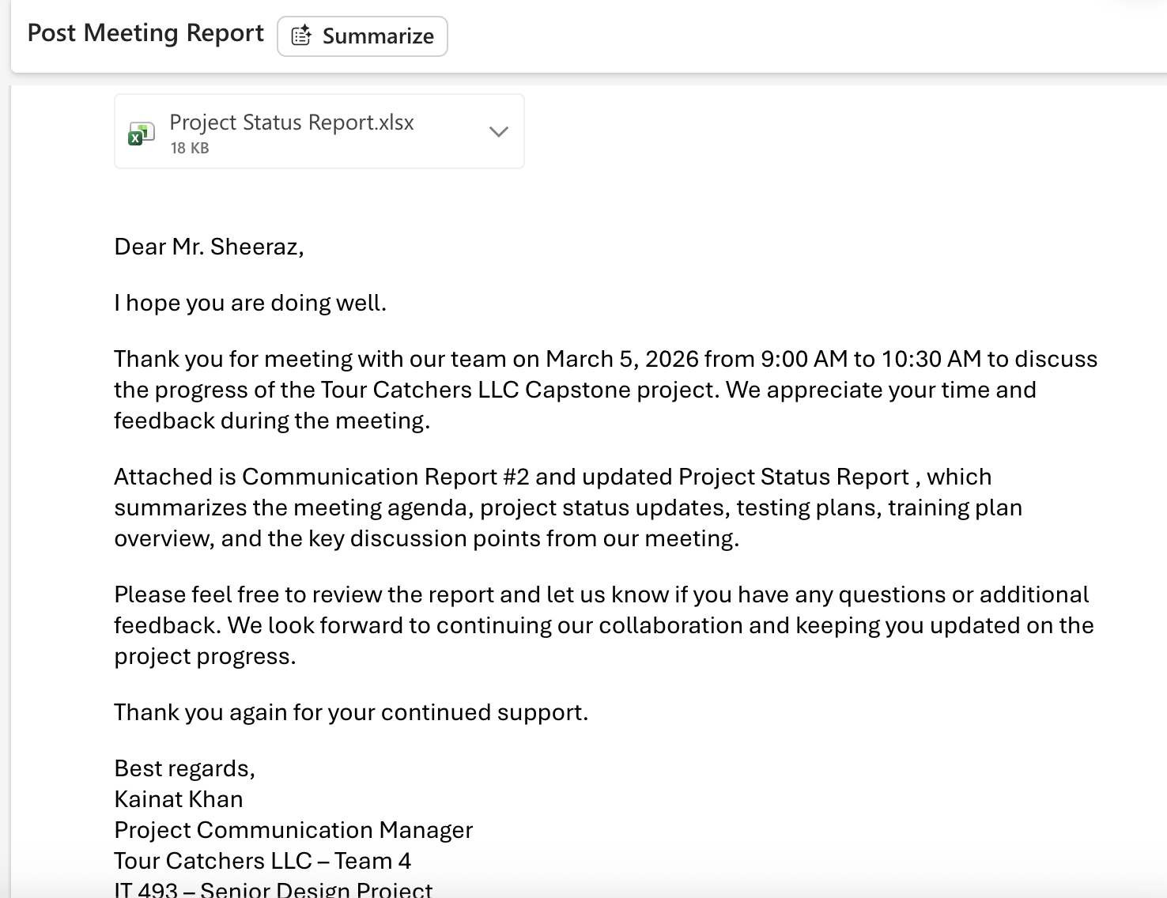

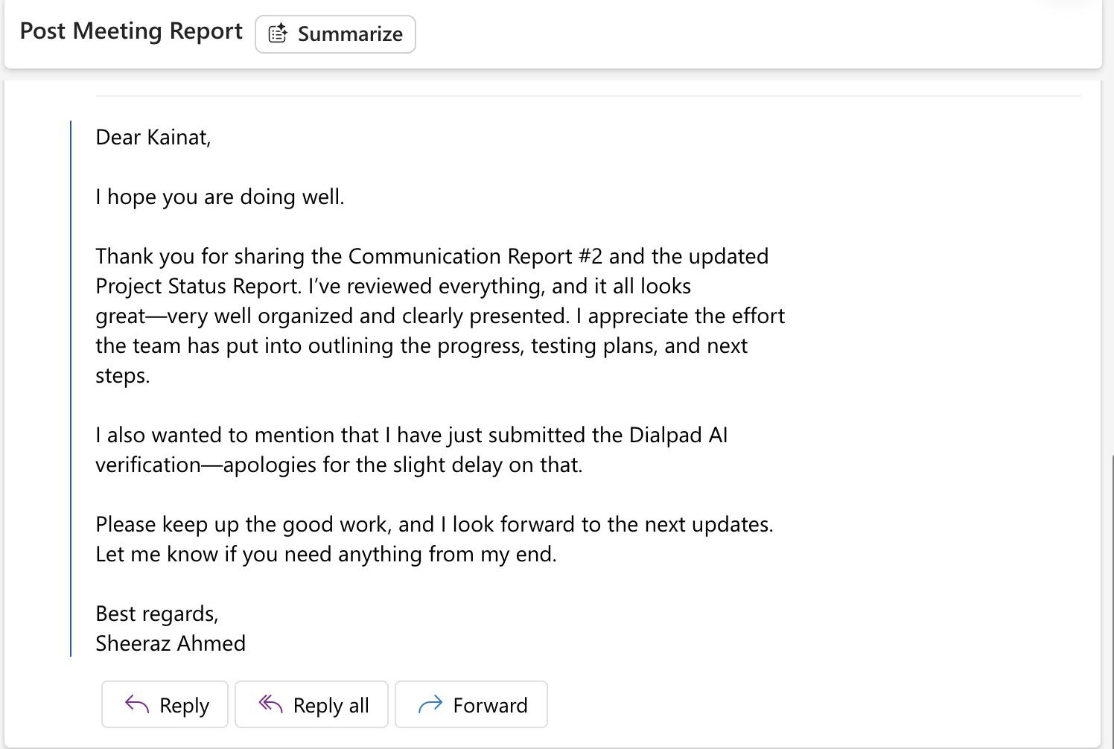

References
Bitrix24. (n.d.). Bitrix24 CRM platform. https://www.bitrix24.com/
Dialpad. (n.d.). AI-powered business communications platform. https://www.dialpad.com/
GeeksforGeeks. (n.d.). What is Agile methodology? https://www.geeksforgeeks.org/what-is-agile-methodology/
GeeksforGeeks. (n.d.). Waterfall model in software engineering. https://www.geeksforgeeks.org/waterfall-model/
Jibraan, A. (2025). IT-493 Assignment 2 Assignment 2- Presentation - DRAFT.pptx. George Mason University.
Team 2026. (2025). IT-493 Assignment 3: Project development plan Assignment 3- Project Devlopment Plan.pptx. George Mason University.
Khan, K. (2025). IT-492 Assignment 4 Assignment 4.pptx. George Mason University.
Mughal, M. A. (2025). IT-492 Assignment 5 Assignment 5- Product Roadmap.pptx. George Mason University.
Mughal, M. A. (2025). IT-492 Assignment 6 Assignment 6- Project Schedule Management.pptx. George Mason University.
Pathak, D. (2025). IT-492 Assignment 7 Assignment 7 - Test Plans & Use Case.pptx. George Mason University.
Mirza, A. (2025). IT-492 Assignment 8 IT493 Assignment 8 - Training Plan.pptx. George Mason University.
Pathak, D. (2025). IT-492 Assignment 10 Assignment 10 - Test Results and Final Test Scripts.pptx. George Mason University.

